THE KINGDOM OF NEW ATLANTIS (WISDOM LAND)
DECENTRALIZED SOVEREIGN GOVERNMENT
PRIME MINISTER’S OFFICE
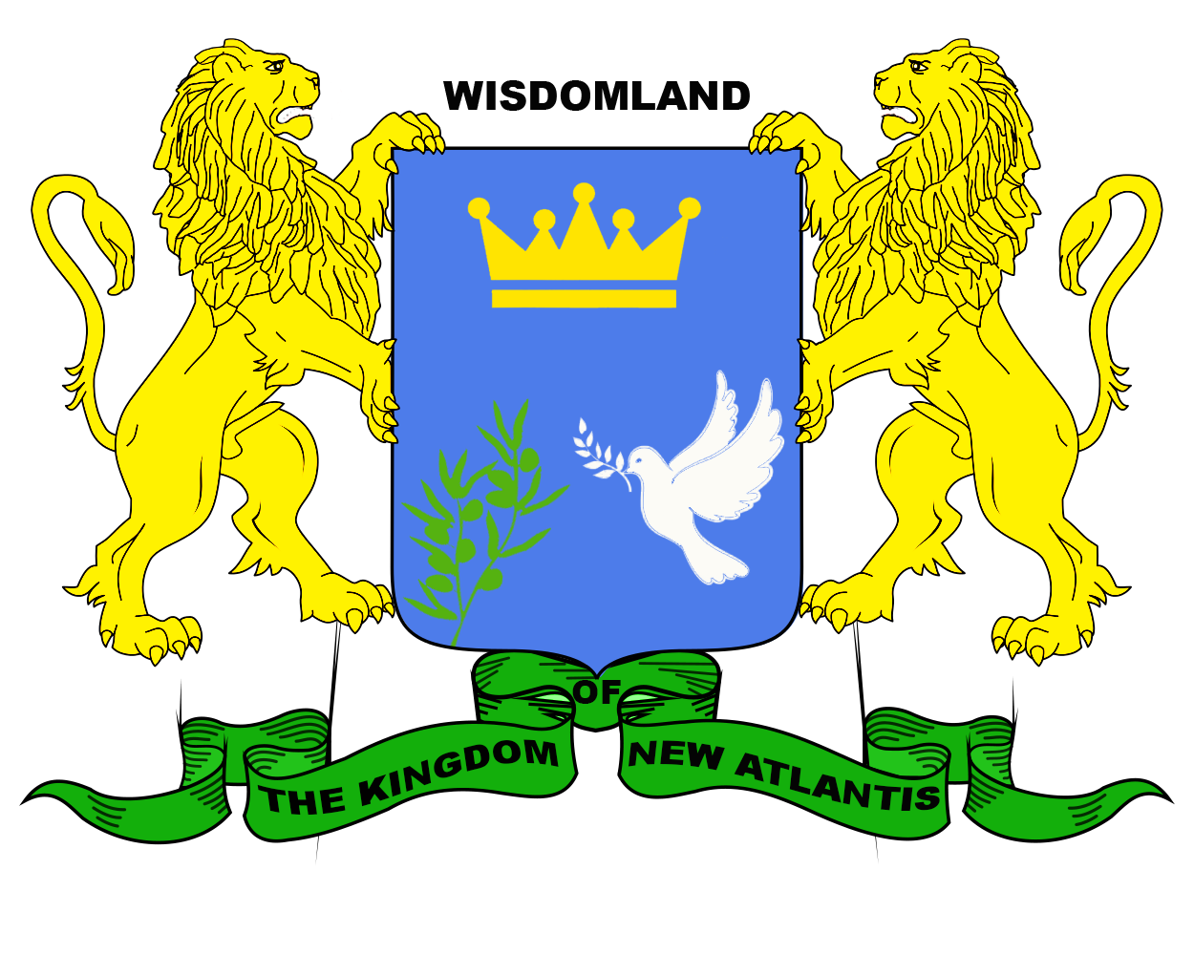

Draft Constitution of The Kingdom of New Atlantis (Wisdom Land)

Draft constitution of The Kingdom of New Atlantis

Preamble
We, The Atlantic Nation, who wishes to establish justice, freedom, security, well-being and development, equality, and justice as high values in a fraternal, pluralistic, and impartial society, based on social harmony and committed to all internal and external systems, peaceful settlement of conflicts and encouragement the interests of its people in exercising sovereignty, announces the following: -
- Ensuring democratic coexistence in accordance with the Constitution and laws and in accordance with a fair economic and social system.
- Strengthening the rule of fair law that guarantees security as an expression of popular will.
- Protecting the Atlantean citizens by exercising human rights, cultures, traditions, languages, and institutions.
- Promoting cultural and economic prosperity to ensure a decent life for every body.
- Implementing the UN sustainable development goals "to achieve human security as a development approach to resolving economic, social, cultural and political issues to achieve a sustainable global peace.
- Creating a progressive democratic society and contributing to the consolidation of peaceful relations and effective cooperation among all the peoples of the earth.
According to these principles and the principle of the people’s freedom to self-determination, the Kingdom, represented by us the Atlantic people, write a constitution that fulfill the generational dream of a prosperous and cohesive society, and a fair kingdom that fulfills the aspirations of human and society. We announce the “Kingdom of New Atlantis (wisdom land)" as a kingdom based on high ethics and as a lighthouse of human beings everywhere.
Constitution of The Kingdom of New Atlantis (Wisdom Land)

Article 1- The Kingdom of New Atlantis (Land of Wisdom)
- Kingdom of constitutional monarchy, a decentralized parliamentary democracy represented by its central sovereign region, its people, its legislative, executive, judicial and decentralized continental regional territories represented by its smart cities in the world.
- A kingdom that exercises its powers in accordance with the Constitution as a constitutional, democratic, and parliamentary monarchy based on the principle of separation and balance of the three powers, democracy, knowledge, values, humanity, citizenship, and partnership, and linking responsibility with accountability.
- A kingdom of humanity, knowledge, values, democratic, social, and indivisible development. Ensures citizens equality in the law without any discrimination based on origin, race, or religion. All beliefs are respected, and their decentralized organization is legally guaranteed by equality between men and women in office, employment, and elections.
- A kingdom that believes in democracy as a path and future and a lifestyle, and the peaceful power transfer, confirm the right of the people to build their own future. Freedom, human dignity, and social justice are the right of every citizen.

Article 2- A Kingdom exercises power according to the Constitution and represented by:
a) The king as a symbol of the Kingdom and its territories.
b) The parliamentary authority representing the people of the Kingdom as a legislative deliberative body with the power to establish and adopt laws.
c- The Prime Minister and the competent ministers as an executive authority.
d- The judiciary as a judicial and legal authority.

Article 3 - The Kingdom of New Atlantis is a natural, valued, human, cognitive and development kingdom, neither political nor ideological trend, focus on human beings, knowledge, and sustainable development.

Article 4- A kingdom that seeks to change the centrality of man and reconsider his role by creating an advanced civilization on the planet far from any kind of pollution.

Article 5- A kingdom where human rights represent a legal statement of the need for human beings to live a human life in every sense of the word. It is a comprehensive, civil, political, cultural, economic, and social human rights as an indivisible and interconnected society, as stated in the Universal Announcement of Human Rights and international conventions.

Article 6. A kingdom where justice is spread equally among members of society, regardless of a person's status, gender, or religion, to achieve safety and security for all and to live without fear of injustice.

Article 7. Kingdom adopts the United Nations 17 sustainable development goals as community development plan in 2030, including environmental issues, a kingdom that will work with all parties concerned regionally and globally to achieve the ambitious goals and objectives of the UN program.
Article 8. The Kingdom of New Atlantis (Wisdom Land) supports the initiative to develop a global environmental charter to provide a comprehensive framework for international environmental law aimed at further consolidating, strengthening the international environmental law, as stated in the UN General resolution dated 10-05-2018 on opening negotiations for a global environmental charter in favor of environmental protocol to achieve environmental goals.

Article 9. The Kingdom's constitutional political system constitutes the state structure, where various legal texts come from, so that justice institutions form the primary lever for the structures of society to achieve progress and sophistication and to provide the right environment for sustainable development.

Article 10. A kingdom that adopts the scientific approach in its research and expectations as a logical result and to develop a broader understanding.

Article 11. In the Kingdom of New Atlantis (Wisdom Land), the philosophy of regional and global peace is a haven for all members of the human family through the development of a civil, valued, cognitive and sustainable, regionally, and globally secured state.

Chapter I: - Sovereignty
Article 12. The official language of the Kingdom:
a) The official language of the state is English.
b) Arabic and Turkish as the second official language.
c) Local, regional, and international languages are allowed.

Article 13- The Kingdom Logo:
The flag consists of:
Blue Color "the color of spirit, dedication, nostalgia, responsibility and loyalty",
White color "color of purity and joy",
Green color feeling hope, freedom, and youth,
Two golden lions’ symbol of knowledge, learning, mental growth, and wealth,
The blue shield and inside "crown" which symbolizes the royal rule and the Atlantic people The " white pigeon and olive branch "symbol of world peace".

Article 14- National Anthem:
The Homeland Anthem approved by the decentralized sovereign government.
Article 15 - The kingdom's Logo
Freedom, equality, brotherhood, love, justice, sustainable development, and global peace.

Article 16 Kingdom
The people are the Authority Source, exercised through their directly elected representatives, in accordance with the provisions of national laws>

Article 17. National sovereignty
National Sovereignty owned by the people and is exercised through its representatives and a free, fair, and public referendum.

Article 18- Nobody, either a group or an individual may retain the right to exercise national sovereignty.
Article 19- Public Direct voting is the right of every mature citizen (18 years and above) of both sexes, enjoys all civil, political, social, and economic rights. All kingdom’s citizens participate in democracy.

Chapter II: - Fundamental Rights

Article 20- Women and men enjoy equally the rights and freedom of civil, political, economic, social, cultural, and environmental contained in national laws, international conventions, and the fight against all forms of discrimination between men and women.

Article 21- All citizens of the Kingdom, either in its sovereign region or in the decentralized territories represented by smart global cities are equally treated in similar circumstances without any discrimination of religious, belief, political, ethnic, sexual, or any other discrimination.

Article 22- Citizens who lives in the Kingdom has the right to have the Atlantean Citizenship in accordance with the Citizenship Rule issued by Parliament.

Article 23- Every citizen has the right to practice freely his own religion and belief, whether alone or in partnership with others without violating the law, or the public order of the Kingdom.

Article 24- Expression right without requesting prior authorization is a natural right available to every human being in the Kingdom provided that the principles of the Kingdom and the public order are not violated.

Article 25- Applying the rule of " No Prior Supervision" to the media broadcasting content without prejudice to everyone's responsibility towards the law which requiring the protection of human values in accordance with the rules on information issued by the decentralized sovereign government and parliament subsequently.

Article 26- The right to form associations within the frameworks of human values and frameworks of regional and global peace.

Article 27- The right to assemble and demonstrate without prejudice to the responsibility of all under the law.

Article 28- The right to respect the individual privacy without prejudice to the restrictions imposed exceptionally or by the laws issued by the decentralized sovereign government and parliament later.

Article 29- The right of everyone to the sanctity of his / her person without prejudice to substantive controls or other laws established by the decentralized sovereign government and legislation subsequently passed by Parliament.

Article 30- Every citizen has the right of sanctity of his / her home. Exceptional cases defined by laws issued by the decentralized sovereign government and later parliament, but with prior notification attached to a statement of the purpose of the entry process.
Article 31- Every citizen has the right of his correspondence privacy in all means of communication except extreme emergency situations determined by the laws issued by the decentralized sovereign government and legislation subsequently approved by parliament, by law with a prior date for this purpose issued by the competent authorities.

Article 32- No person should be deprived from his liberty without the permission of the competent court and in accordance with procedures of law.

Article 33. No punishment for a crime not punishable by law at the time the crime was committed. Nobody should be prevented from being heard by the court. Everyone has the right to be legally represented in the legal and administrative proceedings with the right to support persons with limited means.
Article 34- Securing and promoting adequate assistance for everyone by securing the means of living for the population, achieving the equitable distribution of wealth, establishing comprehensive rules for the eligibility of social security for everyone. He who cannot support himself is entitled to adequate aid for his life under a subsequent law of Parliament.

Article 35 - Providing housing and a suitable environment for living for every citizen.
Article 36- Housing and health insurance for everyone, which should be promoted as per a law issued by the decentralized sovereign government and its subsequent amendments by Parliament.
Article 37. Free education for every citizen up to secondary school by regulating the required standards in government-funded schools with attention to the necessary considerations of private schools under a law issued by the decentralized sovereign government and its subsequent amendments by Parliament.

Article 38- Promoting sustainable development, comprehensive human security, and world peace.

Chapter III: - Kingdom's Legal Political System Structure
Article 39- The kingdom's legal political system plays an important role in the society in terms of objectives and endeavors that achieve the well-being and security of the citizens and the entire state through a range of legal practices and behaviors that play an important role in regulating the work of institutions and forces legally through the regulations and rules in place in pursuit of the well-being and safety of the state internally and externally.

Article 40- The institutions of the Kingdom are the political decision makers and responsible for the application of this political system through:
a) Drawing the dimensions of Atlantic society in terms of goals and efforts to achieve the well-being and security of society and the Kingdom.
b) Make use of all the energies of citizens and strengthen their role by seeking well-being and security.
c) The political system in the Kingdom has supreme authority through its independence as the main factor in any environment where it exists and interacts with other structures in society and economic, development, social, health and cultural structures through decision-making, implementation, and marketing.

Chapter IV

Article 41. King
a. The King is the head of the Kingdom and represents the conscience of the people of the Kingdom of New Atlantis (Wisdom Land), the national character of the Kingdom, the protection of the sovereign neutrality of the Kingdom. reflects kingdom's moral values and common aspirations of the Atlantic people. expressed as a representation and embodiment of the kingdom's legitimate constitutional authority, represent, and strengthen the role of the image of the kingdom inside and outside the Kingdom with discretionary powers that belong to the decentralized sovereign government and later parliament. It is determined by an internal regulation.
b. The King is the guarantor of national independence and the unity of the kingdom's land represented by its central sovereign territory and its decentralized sovereign territories represented by smart cities.
c. Ensures the proper functioning of the public authorities and the continuity of the Kingdom.
d. Awarding of honors

Article 42 The king's powers will be amended after the sovereign territory ownership and the parliament election.
Chapter V Parliament

Article 43- The power of parliament is determined after the ownership of the sovereign territory of the Kingdom and the parliament election .
Article 44. The decentralized sovereign Government represented by the Prime Minister and ministers exercises the duties of Parliament temporarily until the sovereign territory of the Kingdom is owned and parliament is elected.

Chapter VI: - Decentralized sovereign government (executive authority)

Article 45- The executive authority determines the kingdom's general policy and its implementation. The Prime Minister directs the government. He is responsible for national defense. He guarantees the implementation of legislation with the power to enact regulations. He forms ministries and appoints civilian and military posts. He has the right to delegate part of his powers to any of the ministers.

Chapter VII : Prime Minister

Article 46- The Prime Minister considers and decides the public government policy and works to promote its consistency.

Article 47- Prime Minister
- The Prime Minister is the most important political figure in the Kingdom and is considered the supreme president of the country.
- The Prime Minister manages the Council of Ministers in accordance with the principle of individual responsibility and collective consultation. He schedules the council's meetings and signs its decisions.
- The Prime Minister represents the Council of Ministers in all internal and external state affairs associated with the Kingdom’s policy implementation, as per constitution and law.
- Supervises the implementation of regulations, decisions and orders of the decentralized sovereign government, the Ministers council, and the central and decentralized authorities of the Kingdom.
- Issuing binding orders relating to the implementation of tasks.
- Suspend the implementation of ministers, governors, and the heads of the central and decentralized regional bodies decisions if it conflicts with the policy of the Kingdom.
- Developing operational plans and programs for the ministries and their affiliates, forming, preparing, and leading the organizational structure of the ministries.
- Authorizing a member of the Council to sign agreements in the public interest of the country or link with other countries.
- Approve the employment and termination of government officials proposed by ministers.

Chapter VIII : Cabinet
Article 48- Ministers are obliged to take executive actions to carry out the tasks entrusted to them in their areas of competence as per the Constitution and of Ministers Council decisions and to supervise and guide the implementation of these decisions.

Article 49 - Submit proposals on the Council of Ministers action plan in accordance with the rules, and standards specified in the executive regulations of the Prime Minister's Office.
Article 50- Ministerial coordination among ministers on issues requiring coordination. Seeking to resolve disputed issues and inform the Prime Minister.

Article 51- Present any urgent issue within their competence area to the Prime Minister request opinion and guidance with a written note containing a comprehensive explanation and their views.

Article 52- Council of Ministers exercise their functions in accordance with the decision to form the Ministerial Council.

Article 53 - Council of Ministers responsibility is collective and individual responsibility have to implement the general policy of the Kingdom within the frame of laws that determine their competence area, and everyone is accountable to the Prime Minister.

Article 54 - Follow-up of economic development projects and means of implementation.
Article 55- Supervising take care ways of the kingdom's interests in central regions and decentralized territories.

Article 56 - Supervising and follow-up the kingdom's affairs in its foreign relations with countries, organizations, and regional and international bodies in accordance with the law.

Chapter IX : Ministers' Duties and Responsibilities
Article 57- Ministers are appointed and their services terminated by the Prime Minister decision.
Article 58- The executive regulations specify the ministerial tasks and competences assigned to them.
Article 59- Inform the Prime Minister of serious incidents and violations of the Kingdom's regime and sovereignty or related to the laws and decisions implementation or what disrupts them.
Article 60 - Establish and regulate government agencies and public authorities in accordance with the law.

Chapter X : The Judiciary
Article 61- The Judiciary independence is a precondition for the rule of law guarantees the overall independence of the judiciary in both parts “Judicial - Public Prosecution.

Article 62- Abolish and prevent any political or other influence under the penalty of accountability.

Article 63- Providing the right circumstances for the judiciary to achieve independence.

Article 64 - Oblige government and other institutions to respect the judiciary independence.

Article 65- Enshrining the principle of comprehensive judicial independence by technical, administrative, and financial independence.

Article 66- Defines and regulates the structure of the judiciary by an approved law by the Supreme Judicial Council, the Ministry, the Prime Minister, and parliament later.

Article 67- The organizational structure of justice institutions is formed by ministerial decision and in accordance with the rules of the Basic Judiciary.
Article 68. The regulatory law for judiciary work is regulated by a law approved by the decentralized sovereign government and parliament later when it is formed.

Article 69- Considering the Supreme Judicial Council or the Special Judicial Committee as an arm of the judiciary exclusively, whose duty is limited to ensure the proper functioning, dignity and independence of the judiciary and the proper functioning of the courts and considering requests for forgiveness. Opinion on laws on the judiciary, approval of appointments, transfers, formation of disciplinary authorities. Express an opinion on laws related to the judiciary.

Article 70 - Internal formations of the Council and preparation of members and identification of tasks by ministerial decision approved by the Council of Ministers, based on the basic law of the judiciary.

Chapter X: Human Rights Principles, Sustainable Development, Human Security and World Peace

Article 71- Providing constitutional protection of all human rights and providing legal guarantees for the exercise of those rights.

Article 72- Respect the international conventions, instruments, treaties, and conventions related to human beings and consider them as an essential part of the Kingdom's Constitution and laws.

Chapter XI : In Sustainable Development, Human Security and World Peace.

Article 73- The Kingdom gives utmost importance sustainable development issues, human security, regional and global peace, organize sustainable development issues, Society security, and environmental issues by a law to be approved by parliament later.

Chapter XII:

Article 74. In the Constitutional Amendment

The Prime Minister has the right to request an amendment to some articles of the Constitution upon the suggestion of the Council of Ministers, provided that constitutional amendments approval become the decision of the parliament after the sovereign territory ownership and the election of a parliament of the Kingdom.

Dr. Mohammad Alabbadi
Prime Minister
Kingdom of New Atlantis (Wisdom Land)

Issued on 07th October 2021

